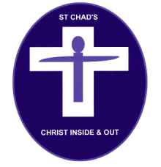St Chad’s Church
Request for a Baptism Service

Please fill in this form and email or return it to the office at the address below. Once we have received it, we will contact you to confirm the date for your baptism and give you a date to attend an informal baptism preparation evening.

Full name of adult or child/children to be baptised:

- First name: Middle name(s):
Surname:

- First name: Middle name(s):
Surname:

Date/s of birth:

Father’s full name (for child baptism/s):
Occupation:

Mother’s full name (for child baptism/s):
Occupation:

Contact address:

Telephone:
Mobile:
E-mail:

Names of Godparents / Sponsors (who must have been baptised):

- First name: Surname:
- First name: Surname:
- First name: Surname:
- First name: Surname:
- First name: Surname:
- First name: Surname:

Data Protection:
- Please kindly provide consent for us to hold your details on our database (you can withdraw consent at any time):
Mother YES/NO*
Father YES/NO*
- Please also let us know if you would like to be on our mailing lists (you can unsubscribe at any time):
Mother Email:
  - I would like to be added to the St. Chad’s Main Email Mailing List YES/NO*
  - I would like to be added to the St. Chad’s Children and Youth Events Email Mailing List YES/NO*

- Father Email:
  - I would like to be added to the St. Chad’s Main Email Mailing List YES/NO*
  - I would like to be added to the St. Chad’s Children and Youth Events Email Mailing List YES/NO*

*please delete as appropriate
Please return this form to St. Chad’s Church office, Eric Rd, Romford, RM6 6JH
Or e-mail it to us at: churchoffice@stchads.church

